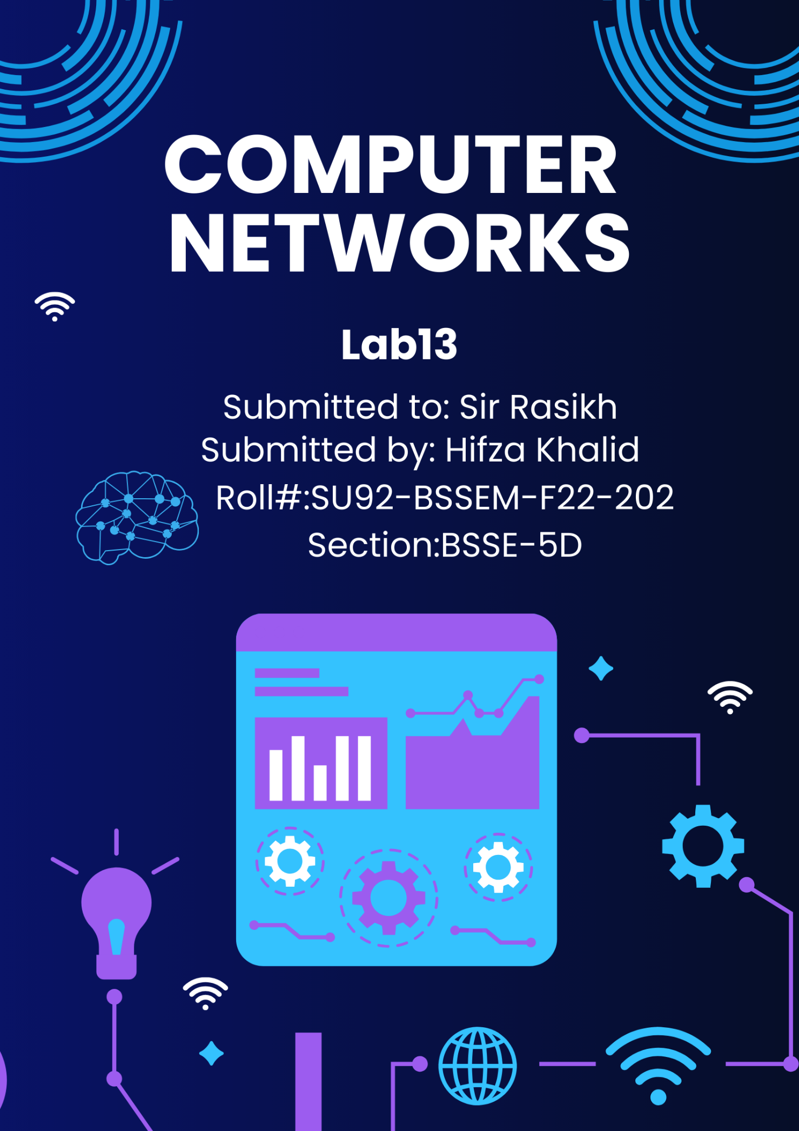

# Lab 13

## Revision: Configure VLAN & Inter-VLAN Routing

**Web-Link:**

https://computernetworking747640215.wordpress.com/2018/07/05/vlanconfiguration-on-a-cisco-switch-in-packet-tracer/

# Lab 13 - Task

## Task 1;

Implement **VLAN** and **Inter-VLAN** Routing in Cisco Packet Tracer, in the network topology of **LAB**-**7** and **LAB-8**

